Article ID: 3085
Article Name The light on my Fridge are flashing
Topic Location: Cooling/Fridge/Broken Damaged
Meta-data: Bulb flashing, refrigerator
Related Articles:
Related Questions:
PNC
DIY
Safety
Link
Email
X Book Engineer
Multimedia
Brand
Article Content:
Flashing light:
The Internal light bulb is loose or has a defect. Fasten or replace the bulb as described in the user instructions.
A flashing light bulb or led lights can also indicate that the ambient temperature is too warm or too cold. Check the temperature classification as indicated on the rating plate.
The proper operation can only be guaranteed for a SN-class appliance in an ambient temperature of +10°C to +32°C.
- Class N = 16-32°C
- Class SN = 10-32°C
- Class ST = 18-38°C
- Class SN/T = 10-38°C
Climate classification indication on rating plate:
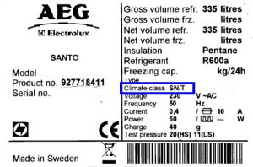

Accessories and spare parts you can find in our web shop.
(webshop)
If none of the above advises solved the problem a service engineer can resolve it for you.
(Book engineer design)

